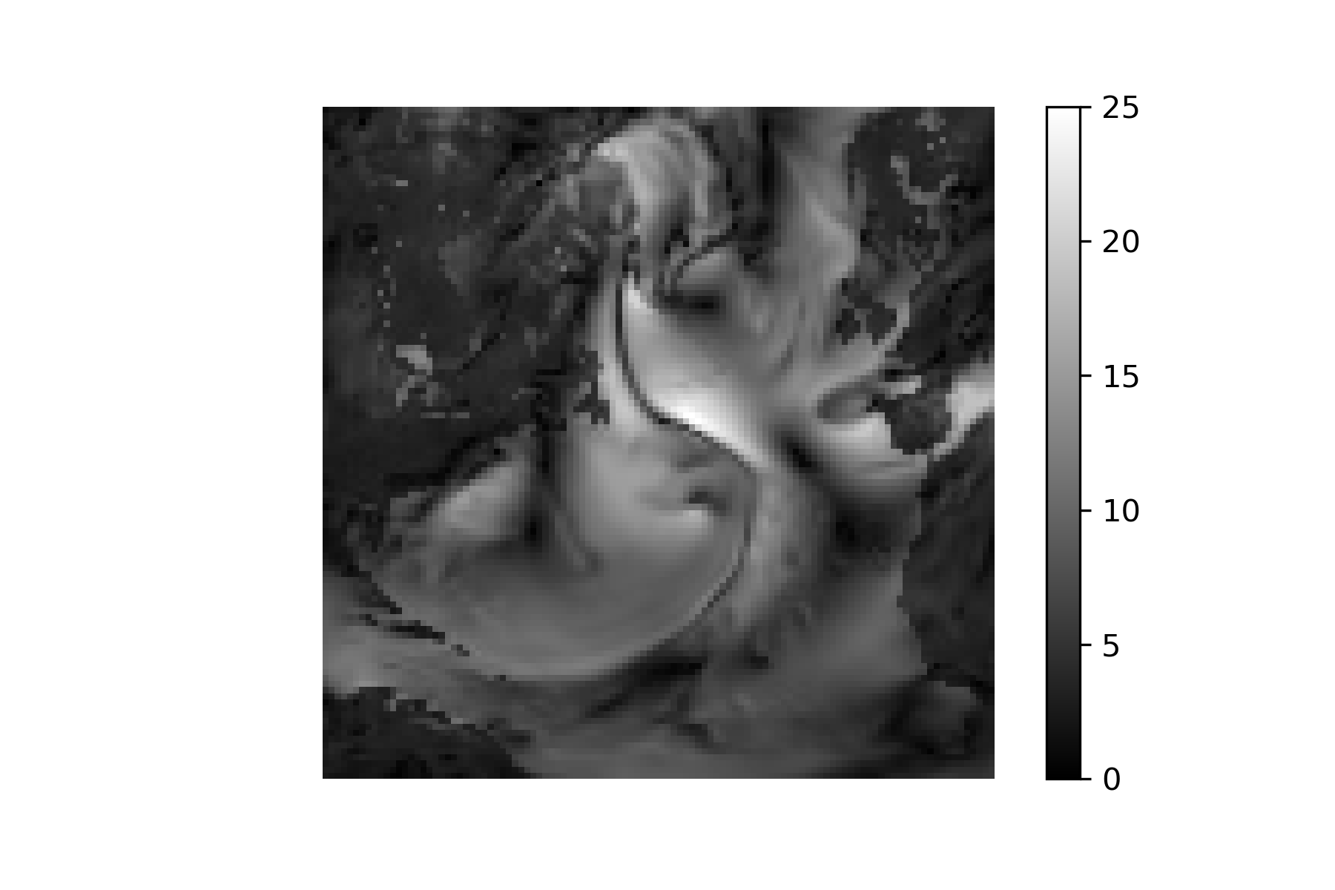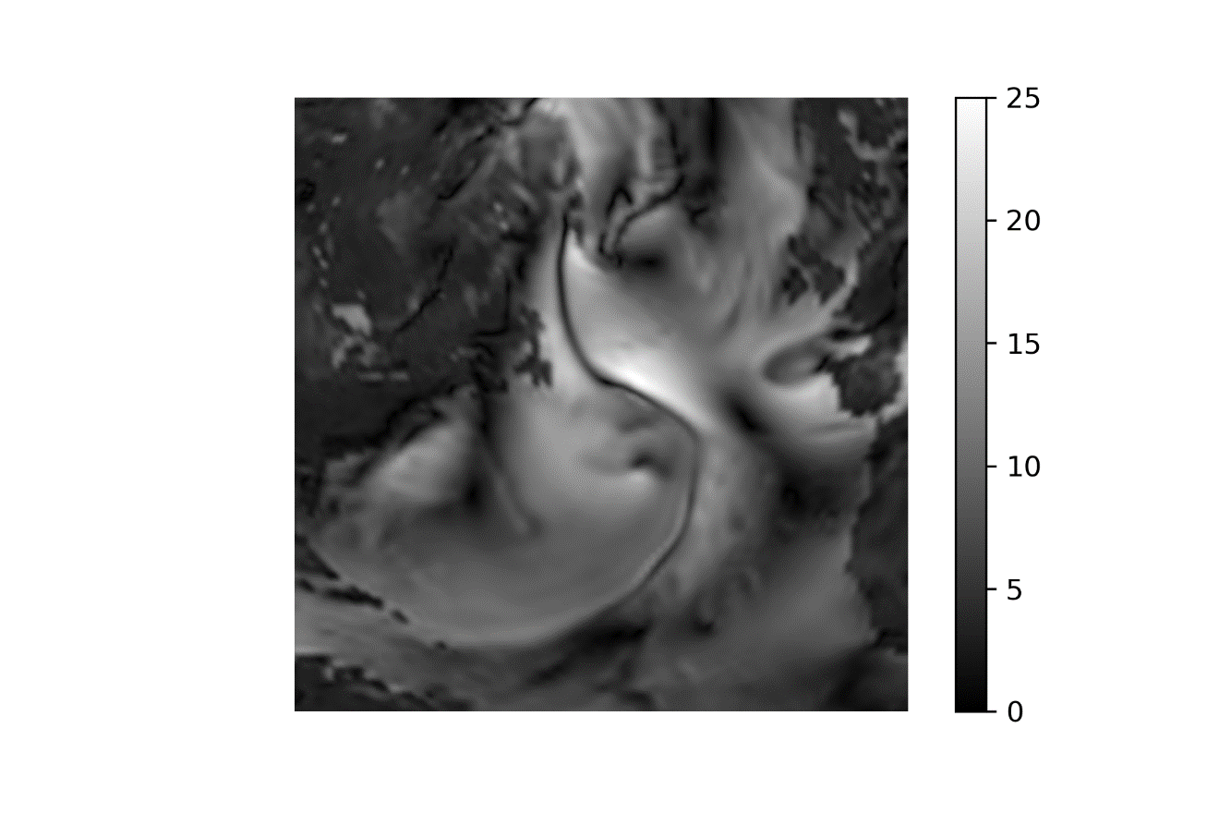

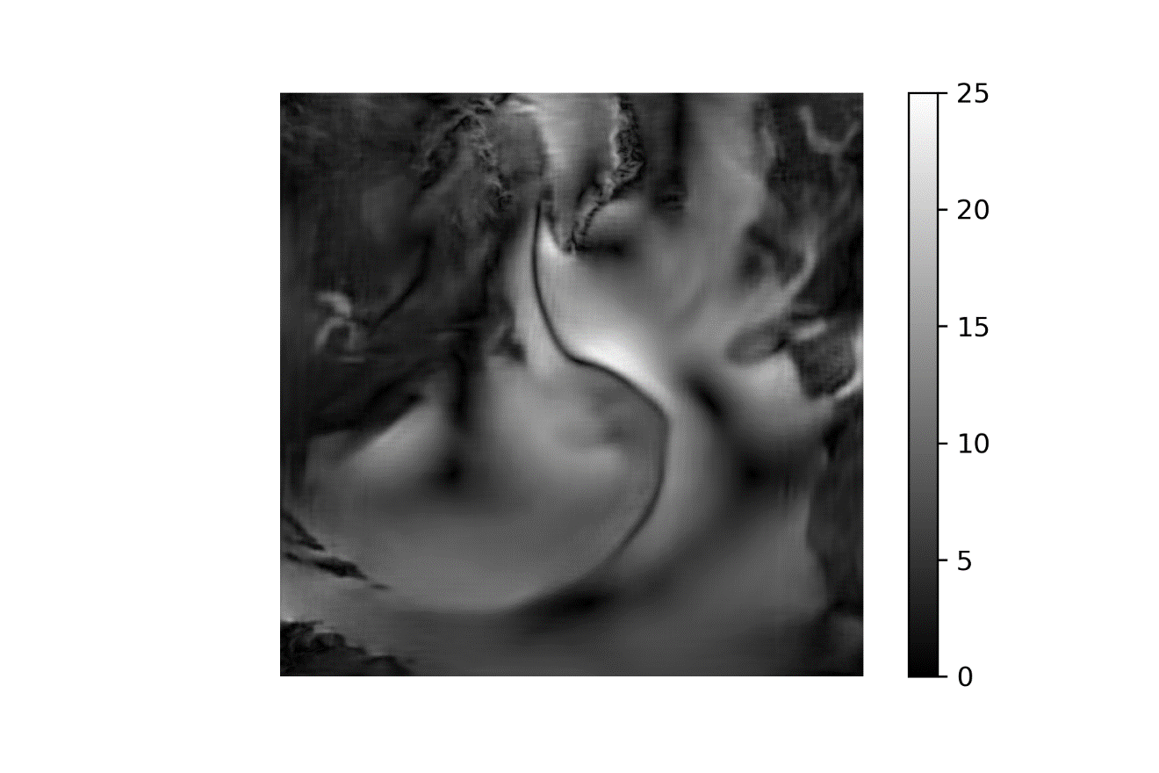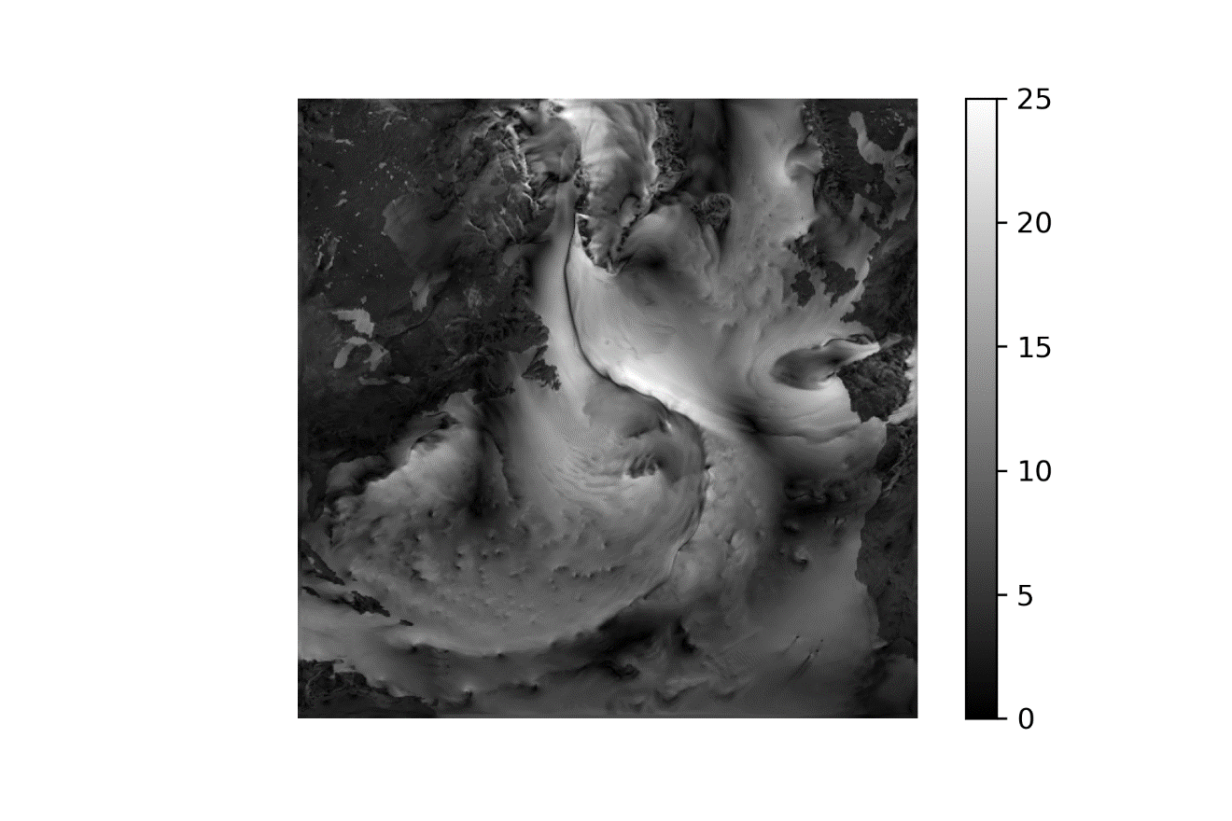

(1 January 2010 Low-Interp-NN-High)

|  |  |  |  |  |  |  |  |  |  |
| --- | --- | --- | --- | --- | --- | --- | --- | --- | --- |
|  | Bicubic interpolation | SRGAN (50 epochs)  train, val | | CNN (50 epochs)  train, val | | NN (135 epochs)  train, val | | NN (200 epochs)  train, val | |
| RMSE (wind, m/s) | 1,435 | 1,398 | 1,451 | 1,386 | 1,496 | 1,354 | 1,475 | 1,313 | 1,325 |
| RMSE (SLP, hPa) | 0,576 | 0,741 | 1,027 | 0,709 | 0,844 | 0,676 | 0,848 | 0,606 | 0,656 |
| RMSE-95 (m/s) | 1,898 | 2,134 | 2,311 | 2,100 | 2,387 | 2,037 | 2,247 | 1,952 | 2,070 |
| PSNR | 35,159 | 34,428 | 32,886 | 35,045 | 32,650 | 34,460 | 33,171 | 35,369 | 34,020 |

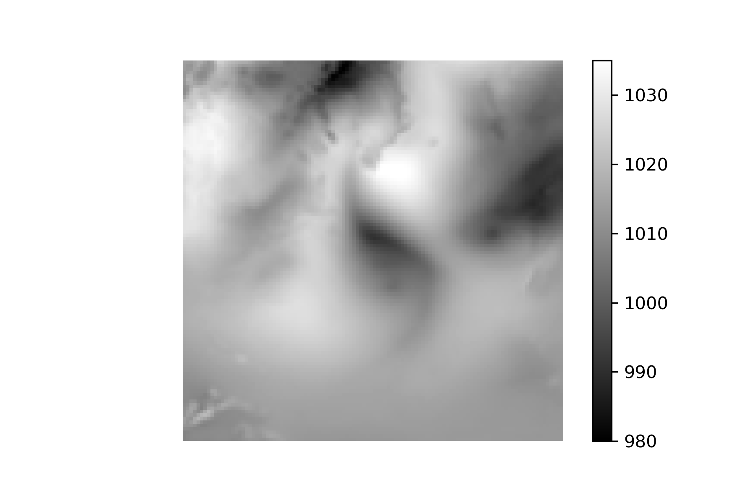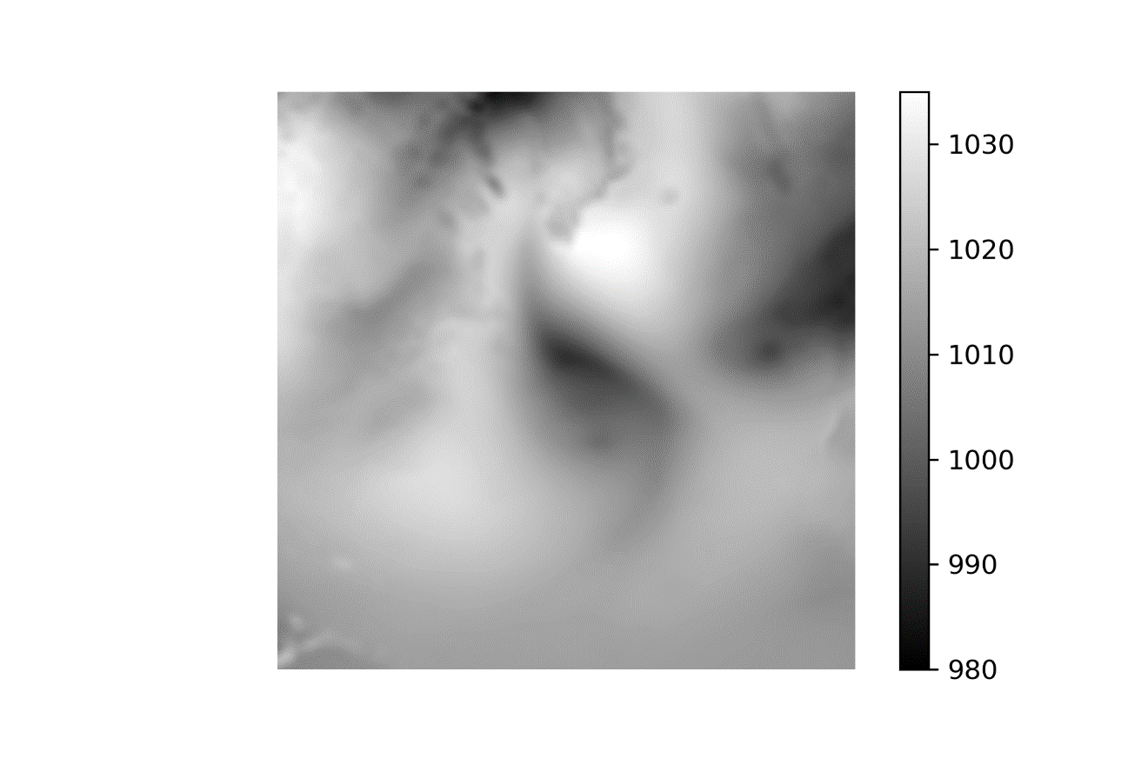

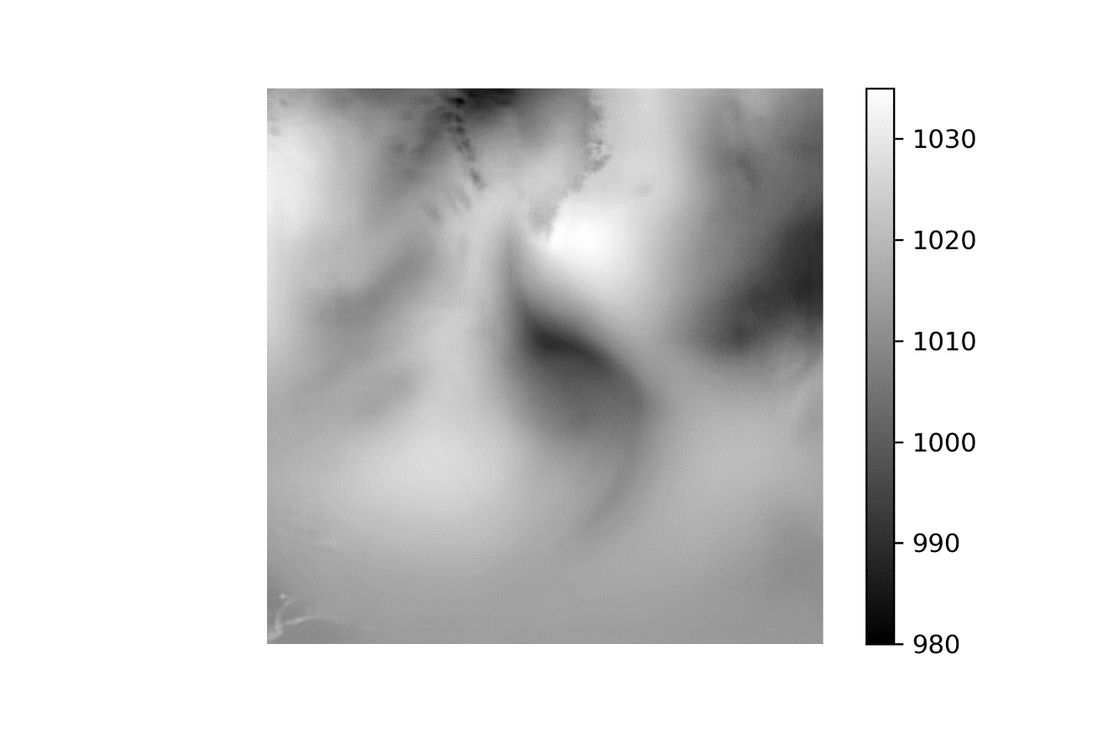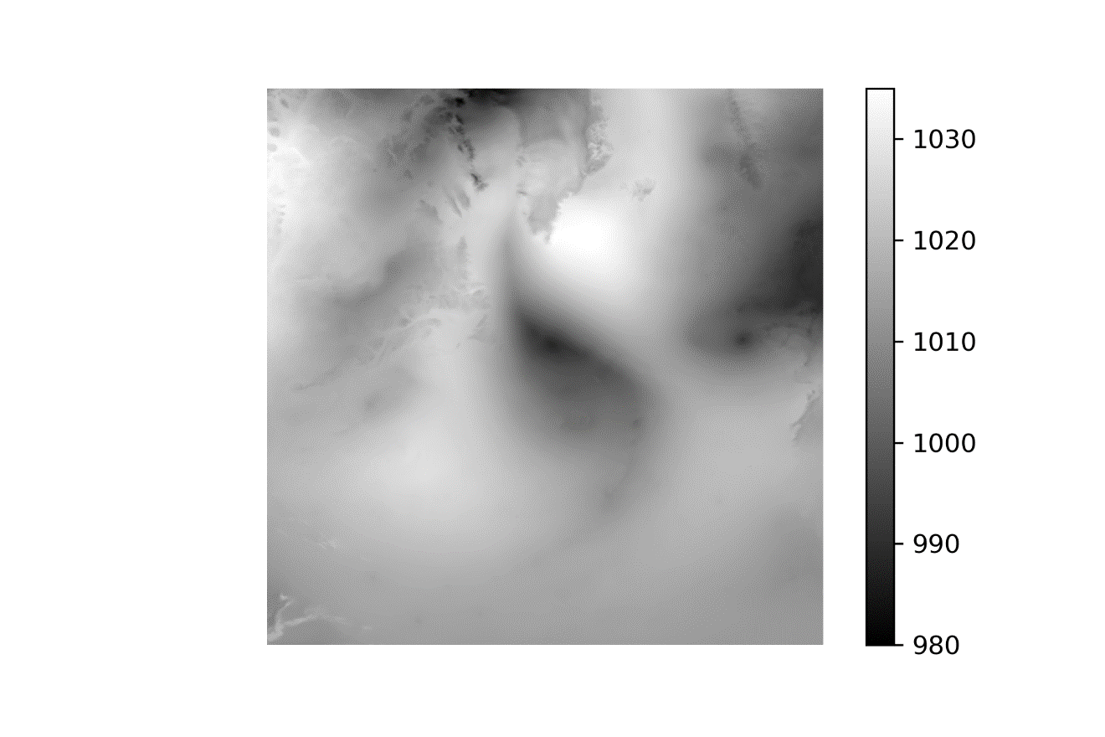

(1 Jul 2010 Low-Interp-NN-High)

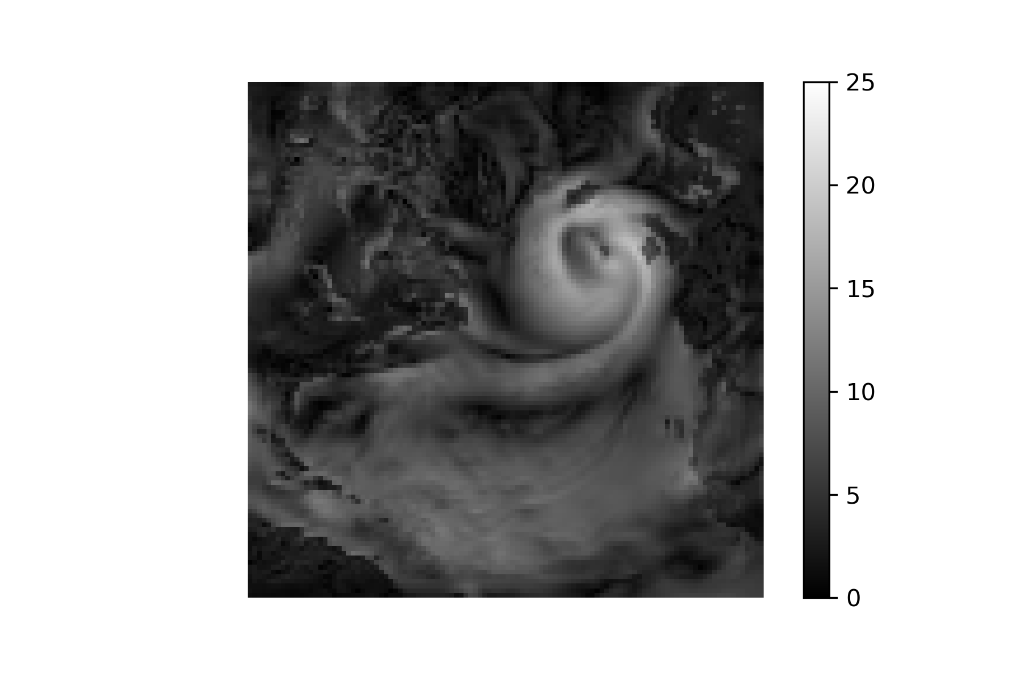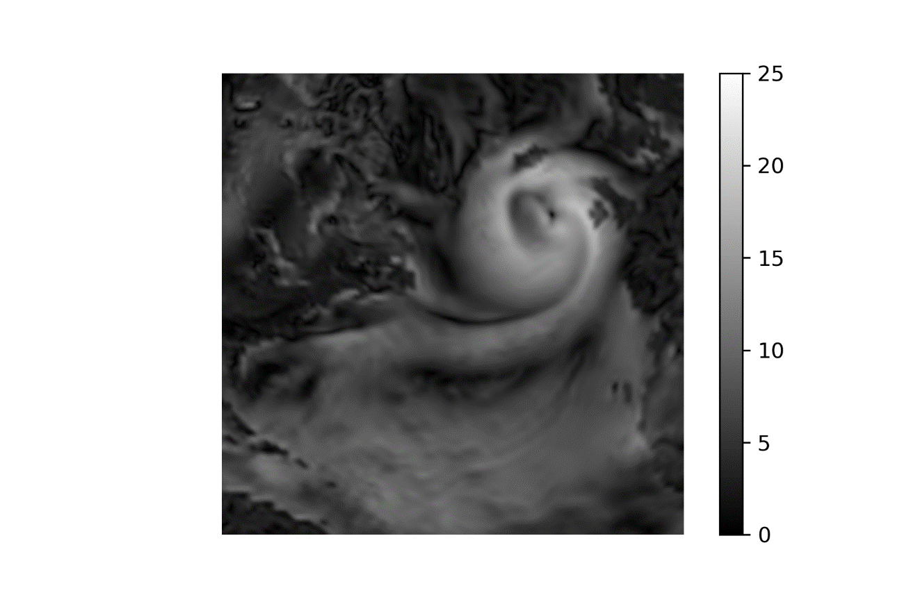

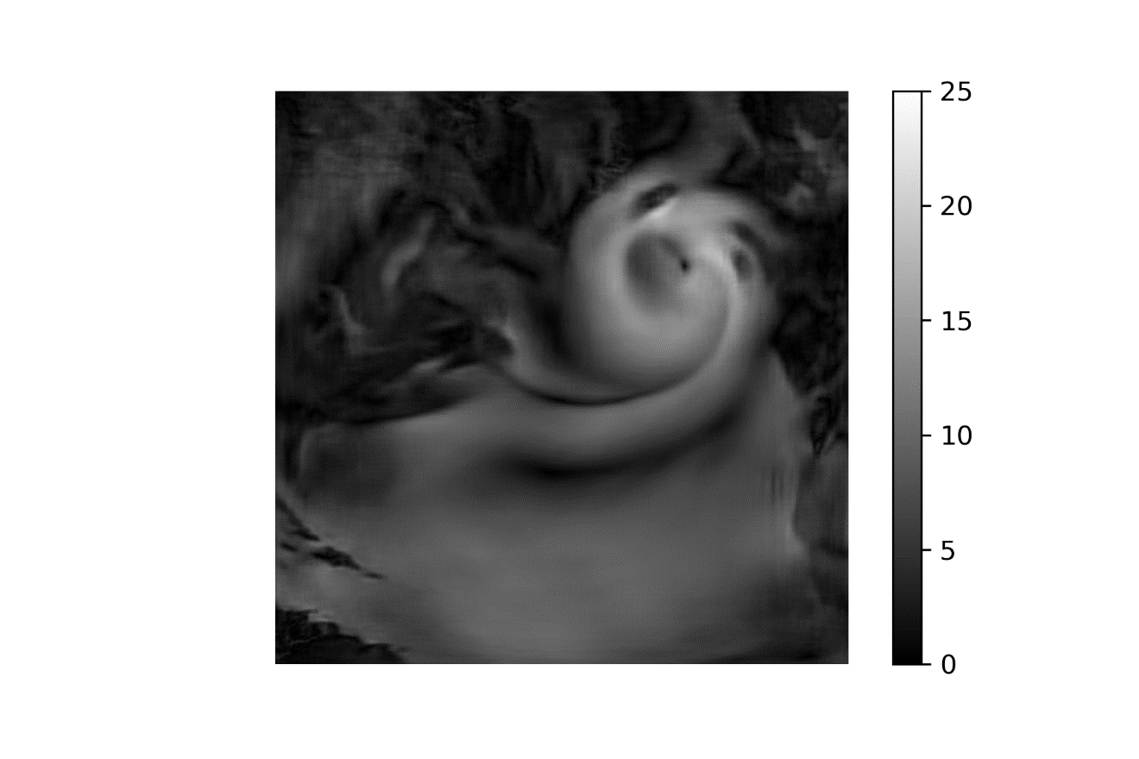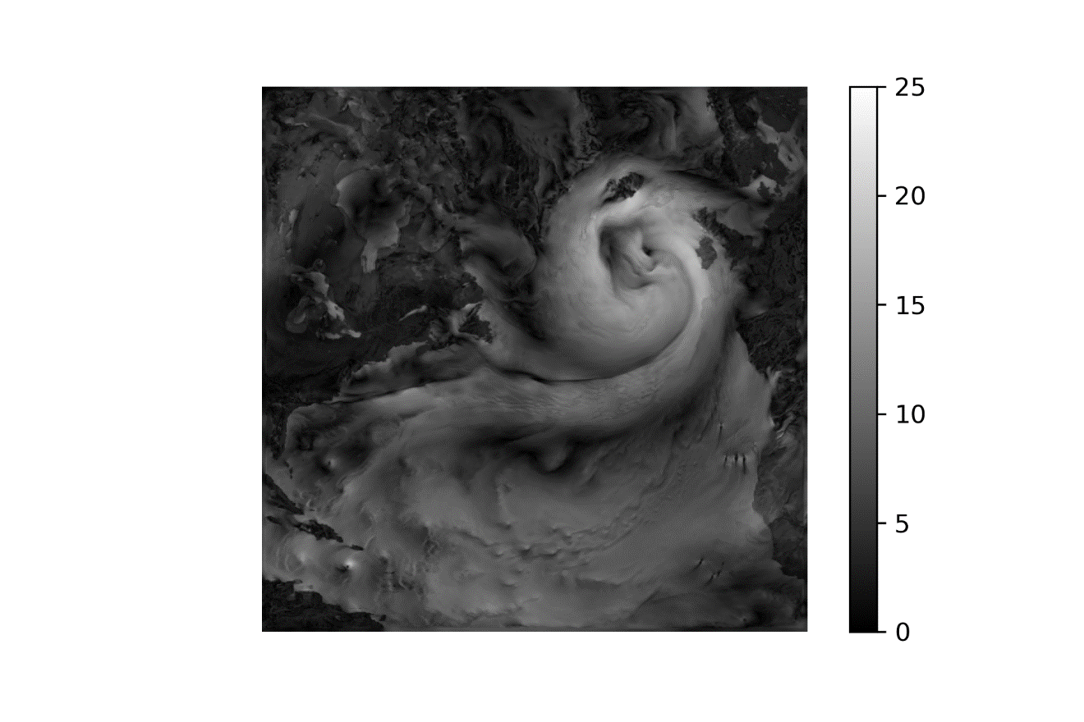

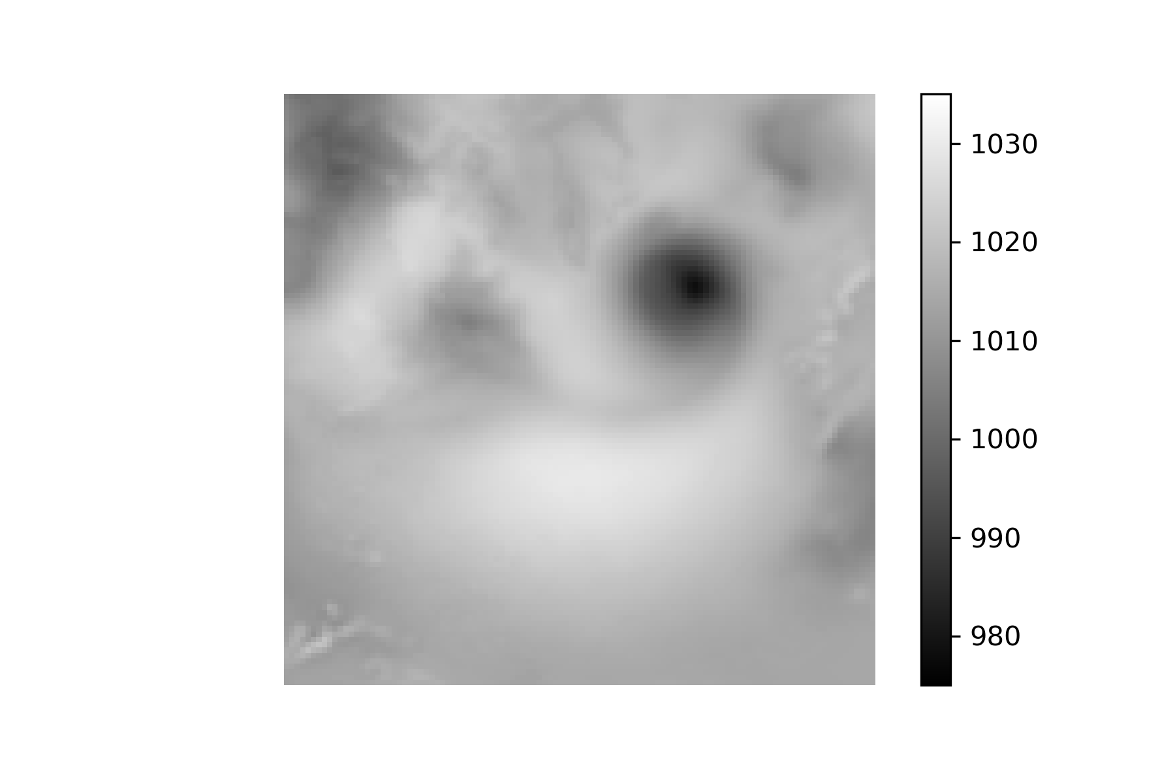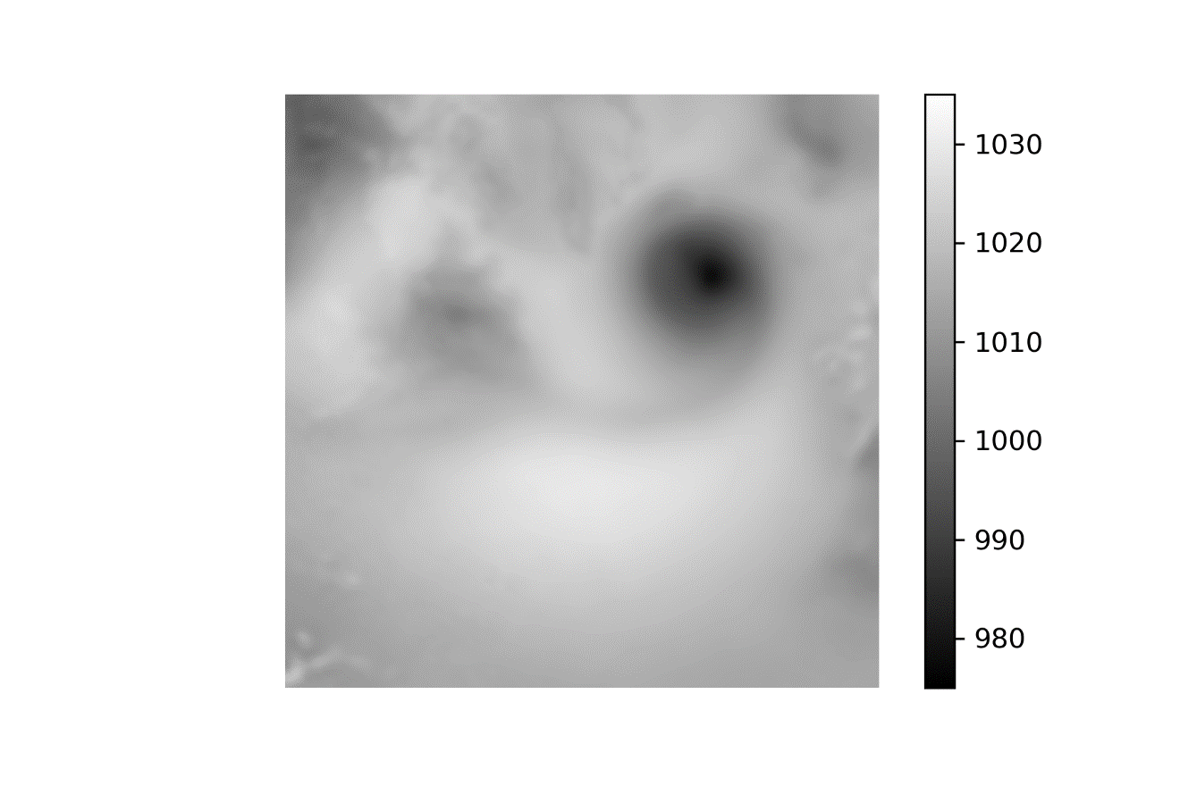

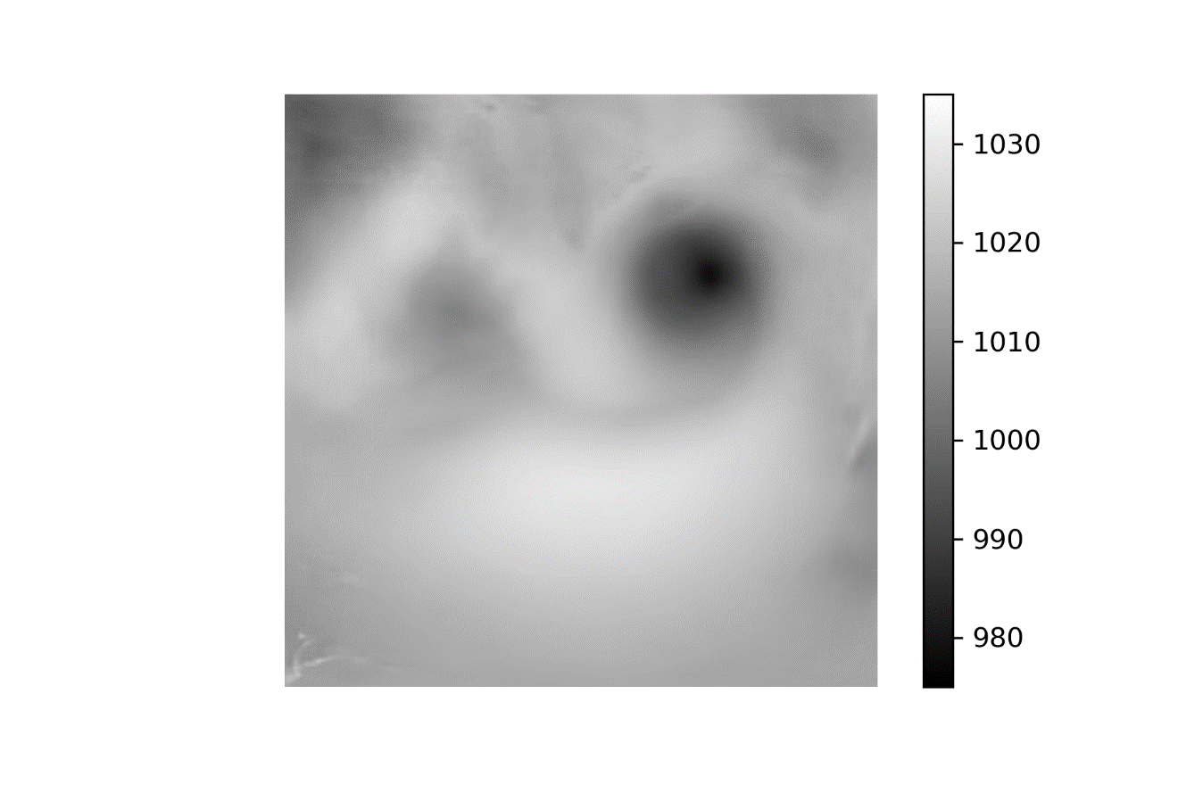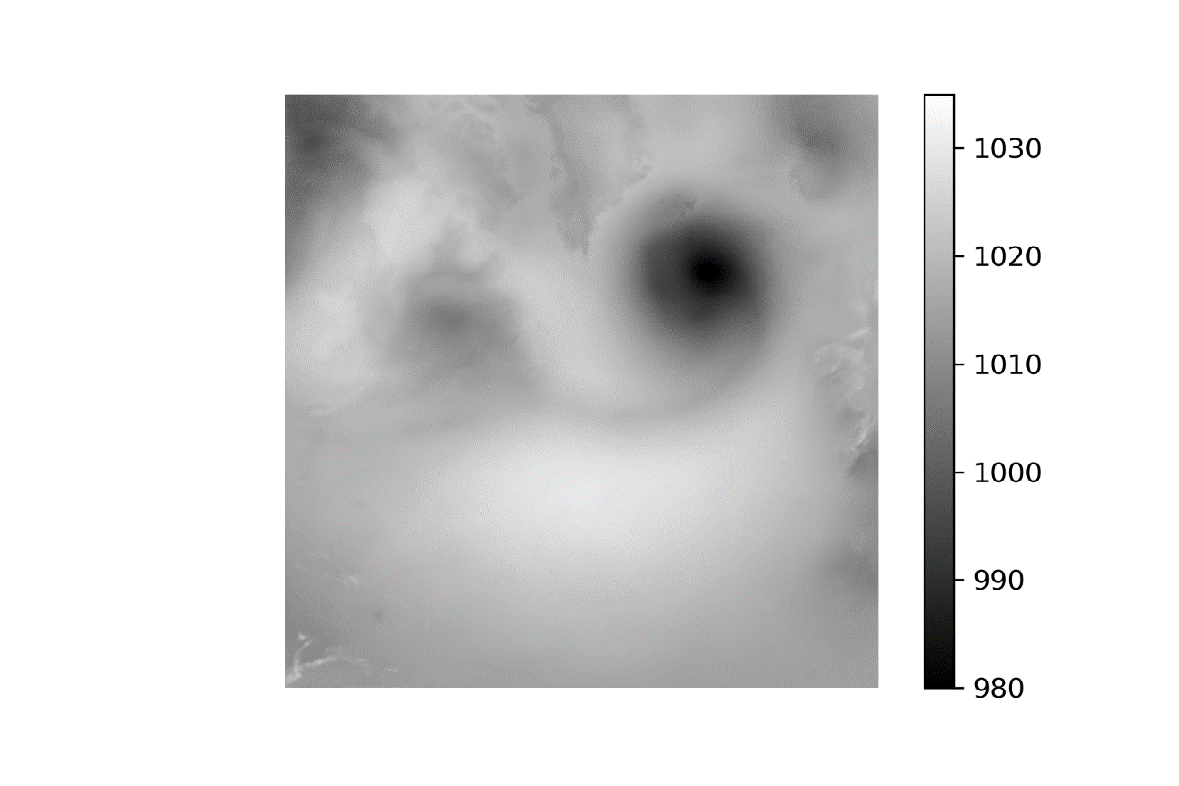

1 Jan 2010 – 50-70-High

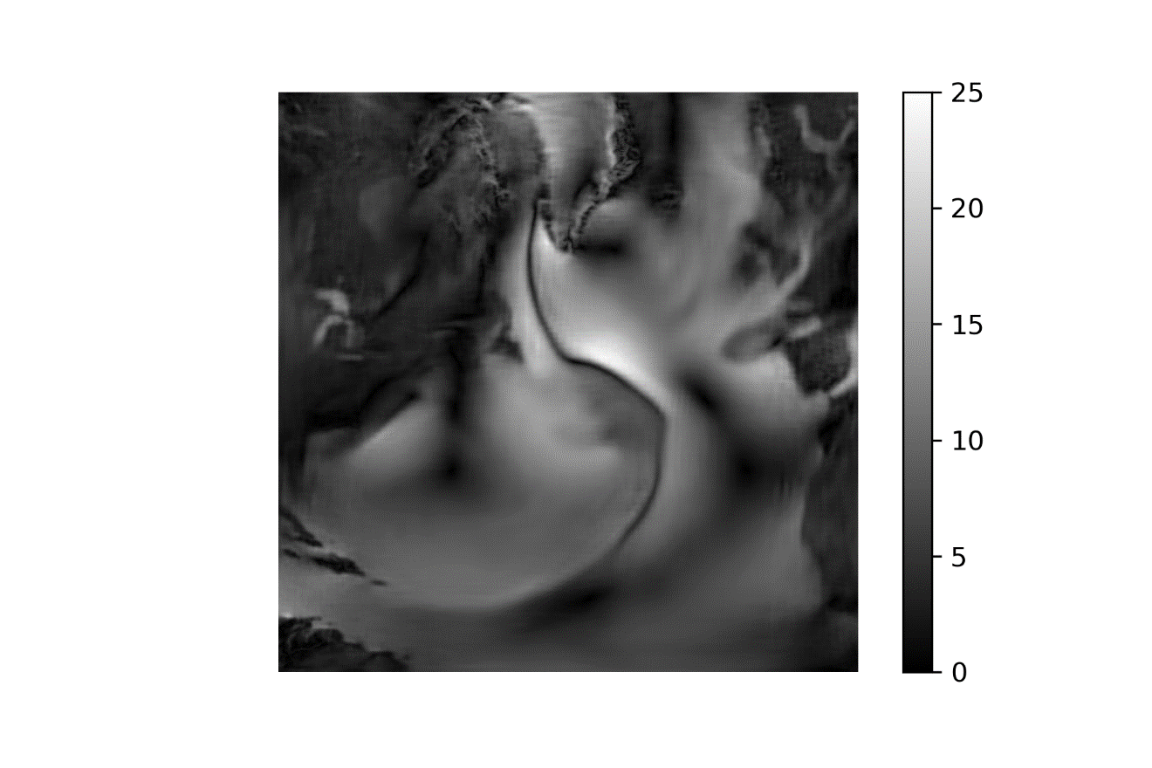

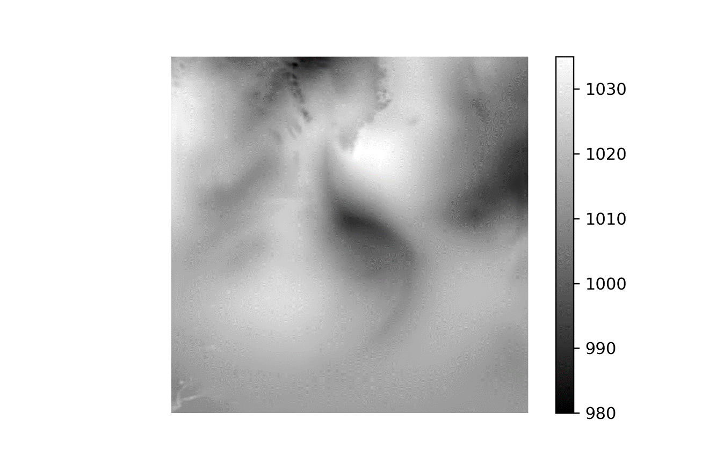

1 Jul 2010 – 50-70-High

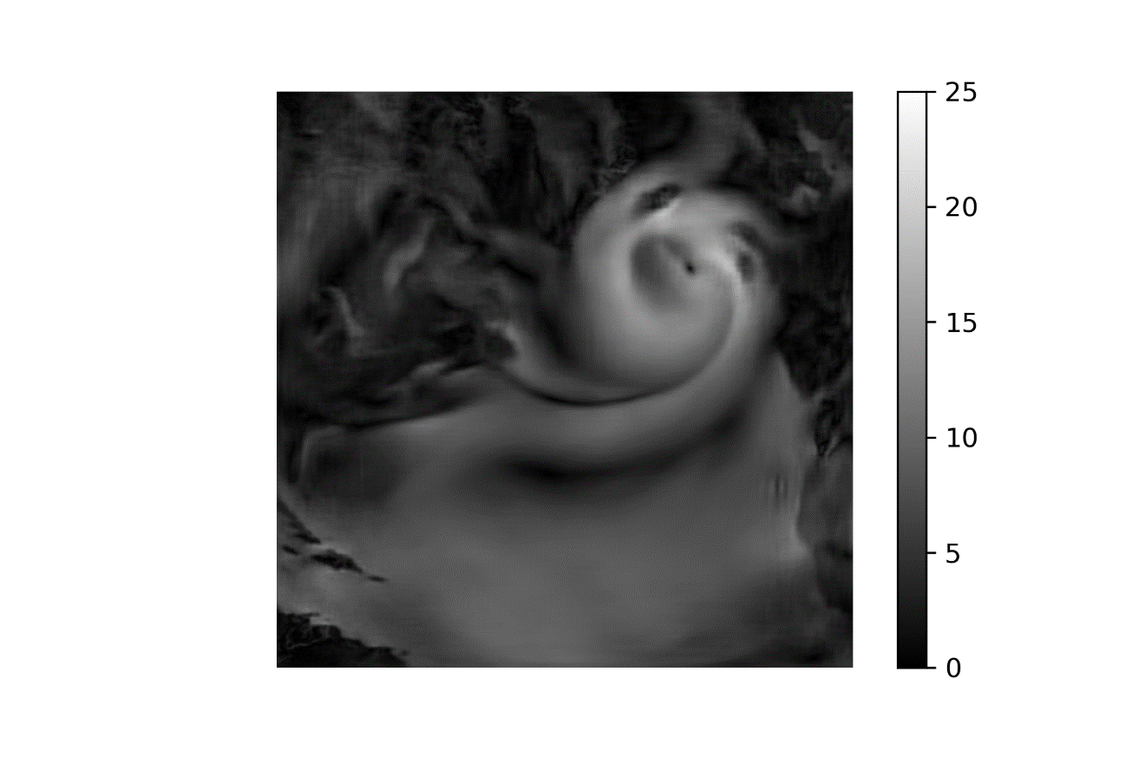

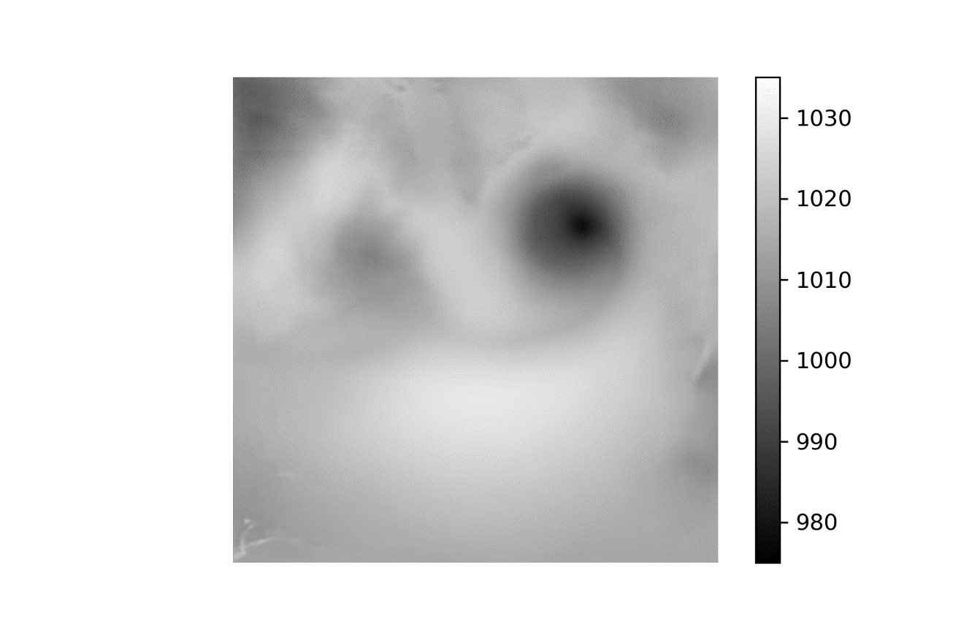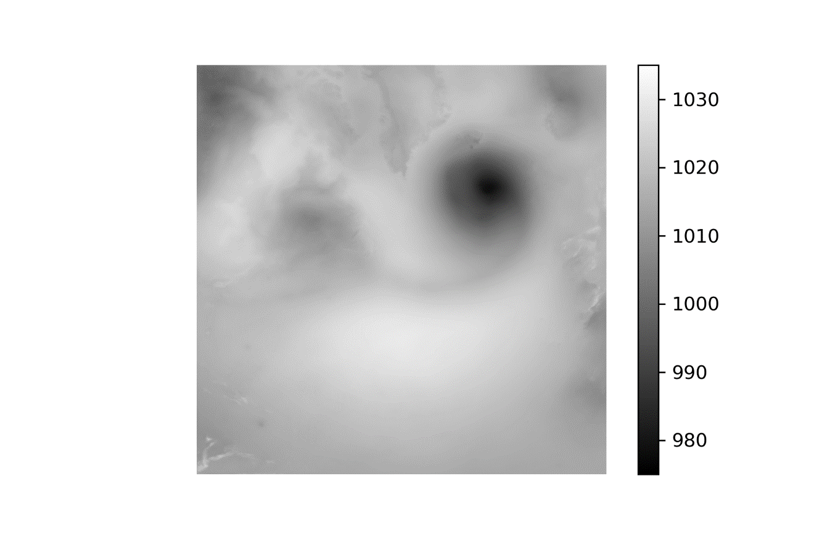

1 Jan 2010 – 50-100-200

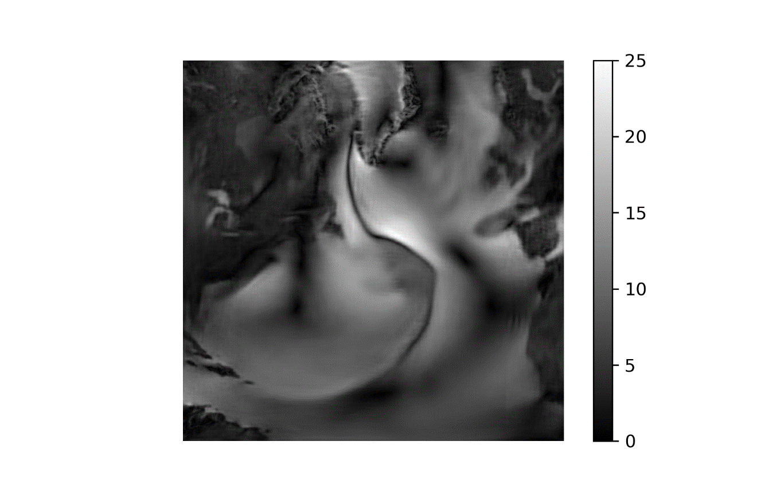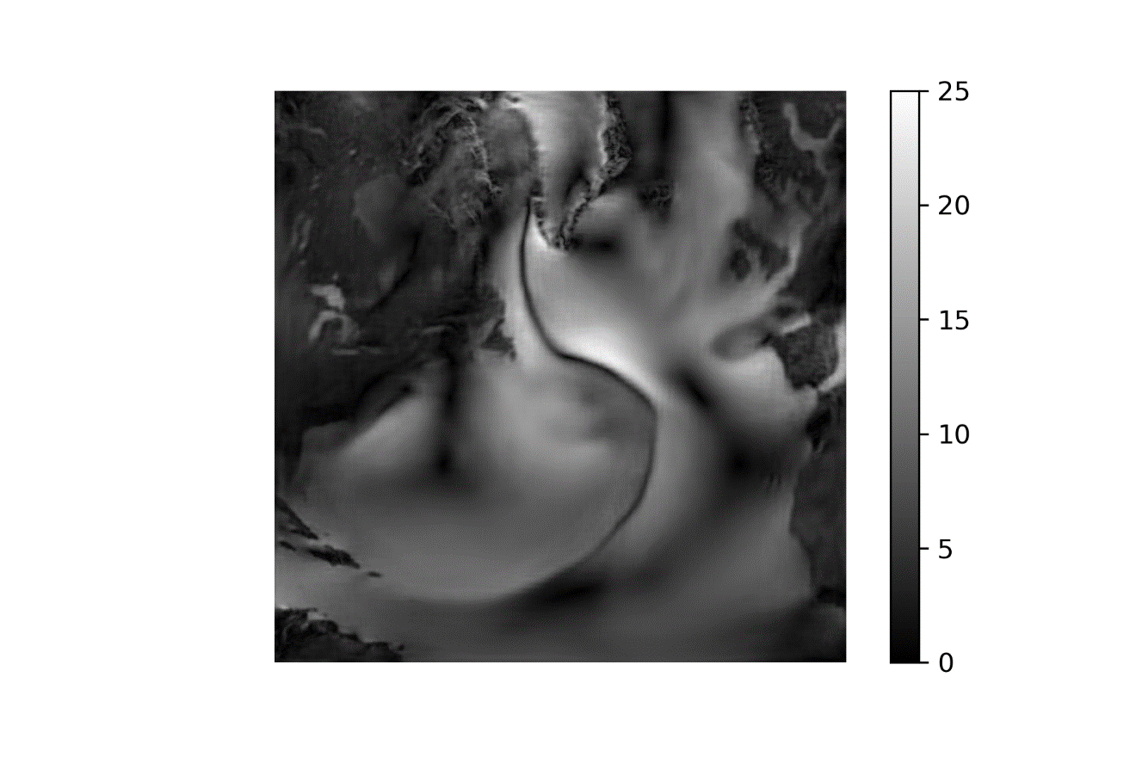

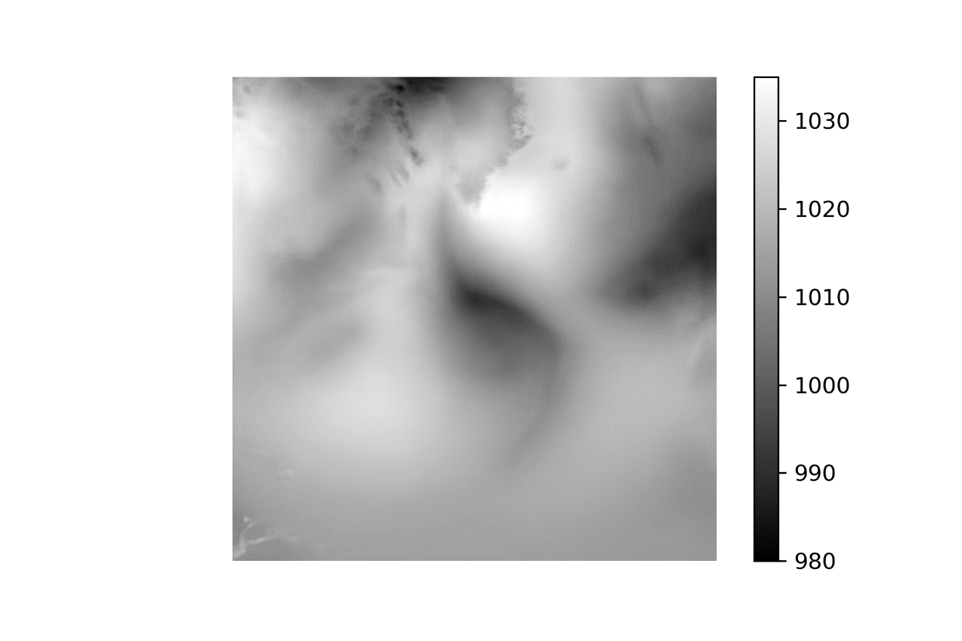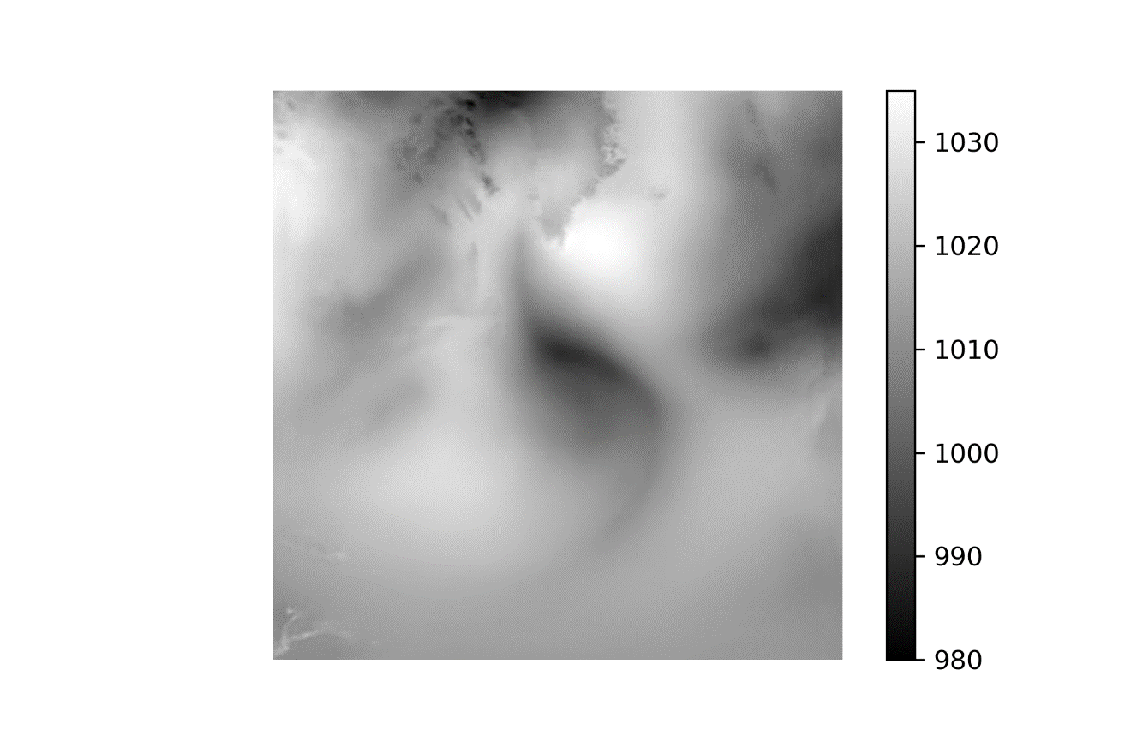

1 Jul 2010 – 50-100-200

